TIMESHEET MODULE

Version: 0.3

Document Details

Document Name | Timesheet Module
Current Version | Version 0.3
Owner | Ravi W

Revision History

Version | Date | Description | Author | Reviewed By
0.1 | 14th July | Initial Draft
0.2 | 19th July | Elaborated BRD
0.3 | 22nd July | Feedback updated by RV

Table of Contents
1. Introduction 4
2. Business needs 4
3. Overall Process description 4
4. Process Flow 4
4.1 Population of Employee Time 4
4.2 Employee Time Entry 6
4.2 Manager confirmation 9
4.2.1 Leave Loss Coverage 12
4.3 Client Timesheets 14
5. Integrations 15
6. Reports 15
7. Scenarios 15
8. Pre-Requisites 17
9. Technical Architecture 17
10. Design Consideration 17
11. Technical Solution Components 17
12. Error Handling and Retry Mechanism 17
13. Data Model 17
14. NFR (Performance, IT Security, etc.) 17
15. Compliance 17

Introduction
This module has the ability to prepopulate time on a monthly basis based on project allocation, maintain during the month, integrate work schedules, absence, capture employee corrections, manager approvals and integrate with Revenue Accrual. It covers population logic across project, WBS, shift, and calendar allocations, along with employee and manager confirmation and approval cycles. The module also handles integration to revenue accrual, including corrections and reversals, along with additional features such as leave loss coverage, advance close, and salary stopping.

Business needs
- Standardize time capture across projects, locations, and work models to ensure accurate effort recording for business operations.
- Strengthen governance over time reporting through controlled validations, corrections, approvals, and cutoff management, minimizing revenue leakage and operational errors.
- Enable reliable downstream financial processing by providing a single source of time data for payroll, revenue accrual, billing, and financial reporting

Overall Process description
- The system pre-populates employee and contractor time based on project allocations, work schedules, calendars, and other workforce data at the beginning of the reporting period.
- Employees review the populated time, record corrections or exceptions where required, and submit the timesheets within the configured reporting cycle.
- Managers validate, approve, or reject submitted time entries, while the system processes workforce changes and enforces business-specific cutoff rules throughout the period.
- The approved time is categorized as billable or non-billable and processed for payroll, revenue accrual, billing, and financial reporting.
- Subsequent corrections or client-driven changes are captured and processed to ensure downstream financial transactions remain accurate.

Process Flow
There will be time entry screen for employees and time confirmation screen for managers. The time entry screen for employees will be prepopulated based on standard hour per country of work/project defined. Employees / contractors are allocated to one of many projects amounting to 100% allocation across projects. The time can be populated at a task level based on the WBS of the project.

4.1 Population of Employee Time
- Monthly process:
  - There will be a monthly program that will run a day or 2 before(before the period is open) the close of the month and populate hours for the next month based on the allocation for the next month (based on the allocation for the current month - do we need a separate screen for setting up the defaulting)
(Should we have separate screen to track if there is an issue in the monthly process) for santhosh
- Daily Process (Only one day or rest of the open period? - Yes)
  - There should be a daily process that is based on action date and do the following. This should be based on a time based logic by country of working (base or deputed)
    - Change of allocation – project closure, new project, %, WBS changes, end date for ee
    - New employees hires - joins on different dates of the month and get allocated to a project under a shift . If they are under training or on bench they are still allocated to a project as unbilled resource
    - Exits - can also be terminated or separate from service during the course of the month or on the last day So Timesheet would be applicable till the last working day of the employee and if the already created timesheet is for a longer period, the date until which the timesheet is applicable should be marked.
    - Termination reversal
    - Deputations
    - Transfers
    - Shift details update
(Need some examples on the difference b/w Change of allocation(projects change), Deputations (shot term location change), Transfers(base location change)
  - The above change in data can also be retrospective (with a stipulated control for how long in can be backdated). As a part of the current solution design, we can allow for handling upto 3 months backdated(this is needed as a config in control table ), and it would be good to control this period through a configuration.
  - Any corrections to data for the back period should be maintained for use in the current/subsequent accrual cycle.
- The time data that is populated is sourced from the following details:
(Should we give provision for calendar creation in time module or not) – dev team will decide -going to pull it from oracle fusion
  - Standard Hours
    - Corporate Calendar & Corporate Standard hours by Country
      - the work days and holidays are defined at a country level. Corporate holidays may be at a city level, if required are populated and used as base
    - Client Holiday Calendar
      - Client Holiday Calendars, may be tracked country wise for Client work days and holidays.
    - Project Standard Hours
      - Project specific standard hours should be maintained country wise
    - Shift Configuration (What are the different types of shift we have need to explore whether from oracle it will come or we need to maintain it) – will come from HCM need to explore
      - Employee can be working in normal day shift or other shifts which can be different for different clients and hours may also vary. Number of days working and hours per employee can also vary
      - Shift calendar should override Client calendar (Corporate)
- Employee Standard hours
  - Standard hours for a person is based on the Location (Country) of a person (source could be HR systems) and the work calendars and shift schedules
  - Country of the person can be determined from HR systems, based on
    - Deputation – while base location is a specific city or a country there can be short term and long term deputation. This can happen for a full period or parts crossing periods also
    - Transfers – employee can get transferred from base to a different locations during or end of a period
  - The standard hours for a day, applicable for an employee is identified from the standard hours defined at the corporate level based on the country in which the employee is working.
  - For computing/defaulting project hours, the Client standard hours should be considered.
    - Any difference between the Corporate standard hours and total defaulted billable hours across all projects, if greater than zero, should be considered as Unbilled and defaulted with the unbilled reason ‘Billing Loss’. This reason should not be allowed for editing, similar to leave
  - Project allocation
    - Employees / contractors (ee) are allocated to one of many projects amounting to 100% allocation across projects. There is a standard hour per country of work / project and this is used to calculate timesheet hours per project.
    - WBS – employees are allocated to WBS with a WBS allocation%. The project timesheet hours for an employee will further be allocated to the WBS tasks based on this %.
    - Allocation start dates and end dates, should be appropriately handled for populating time against a project including mid-month allocation start and allocation releases.
  - Absence
    - Leave should flow from Absence module and will not be a selection. If an employee is on leave for a day of the week, then billed hours for that day should be marked as 0 for all projects. The unbilled reason can be shown as “Leave” but while selecting unbilled reason for non billable hours, it should not be displayed in the drop down.
    - LoP, Long leave - this should be treated as not available hours and should not come in numerator or denominator in any calculation / reports
    - Only the absence types that are applicable as per the organization policy for time management should be considered (Do we need this as a part of config)
(For Aug a person is assigned for a project for from 1st till 31st but on 15th he is going for a medical leave for rest of the Aug month what is the flow) based on the oracle needs to check

4.2 Employee Time Entry
Employee views the timesheet on a weekly basis to confirm the time after making any corrections to the hours, if needed.
Data field | Description | Field Type | Input Type | Source System | Mandatory  (Y/N) | Sample Data
Header
Project name | Name of the project | Varchar | Auto populated
Project number | Unique id of the project | Varchar | Auto populated
Select week | Option to select week within the month |  | Auto populated as the current week
Line level
Days | List all the days with dates within the week | Character | Auto populated based on the week selected
Task | Based on the WBS of the project | Character | Auto populated
Shift type | Type of shift like regular or night | Character | Auto populated
Billable hours | Prepopulated but editable | Number | Auto populated
Non billable hours | Prepopulated but editable | Number | Auto populated
Unbilled reasons | Enter the unbilled reasons like customer holiday, training, travel | Character | Input

Rules:
- Show the current week by default
- Hours should be at task level for each day of the week.
- Ability to modify time by blocks of 15 minutes - (<> done and up arrow in the side which will increment by 15 mins)
- Employee cannot add hours for the future weeks.
- Employees cannot enter more than 24 hours a day (Allocation can go to more that 100%)
- Option to save so that employee can change the hours daily also and save intermittently.
- Option to submit the timesheet for approval weekly based on customer requirements. There will be a cut off date before which employees must submit the timesheet.
  - Job required - weekly cut off day and time based on base location of employee. If employees don’t submit, status should be “Defaulted”
- If there is non billable hours, then unbilled reason is mandatory
- If employee has not submitted timesheet before the cut off date/time, then there should be a job that would make the status of the timesheet for those employees as defaulted.
- If the timesheet is rejected, employees can edit and submit again till the delivery cut off date.
(9 different status for timesheet)
Manager can override and approve

- Payroll cutoff(26th July)
- MEC (period Close)(31st july )
- Finance Cutoff (After 2nd Aug)
- Delivery cutoff(weekly/ monthly after 2nd Aug)
- Client Cutoff(before 10th Aug(Net 30) )
- Book Close
Here which cutoff can happen adjustment because employee needs to resubmit it.

Action | Status
While logging in | Not yet submitted
After submission | Submitted
After approval | Approved
After rejection | Rejected
Auto submitted by system | Defaulted
Manager rejects and employee submits again after the weekly cut off | Late submission

Sample screens
Web application ( What if a person is linked to multiple project) we need to bring all
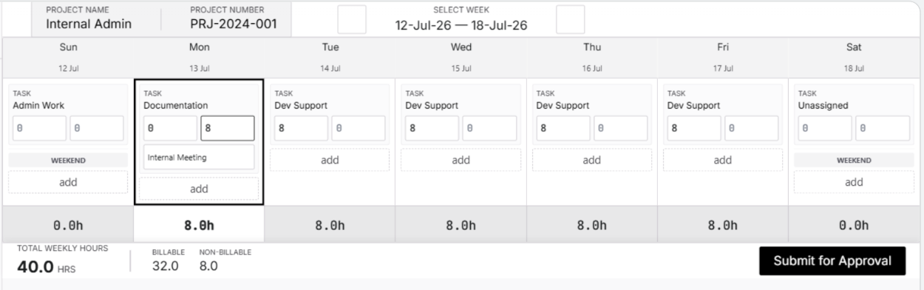

Mobile application
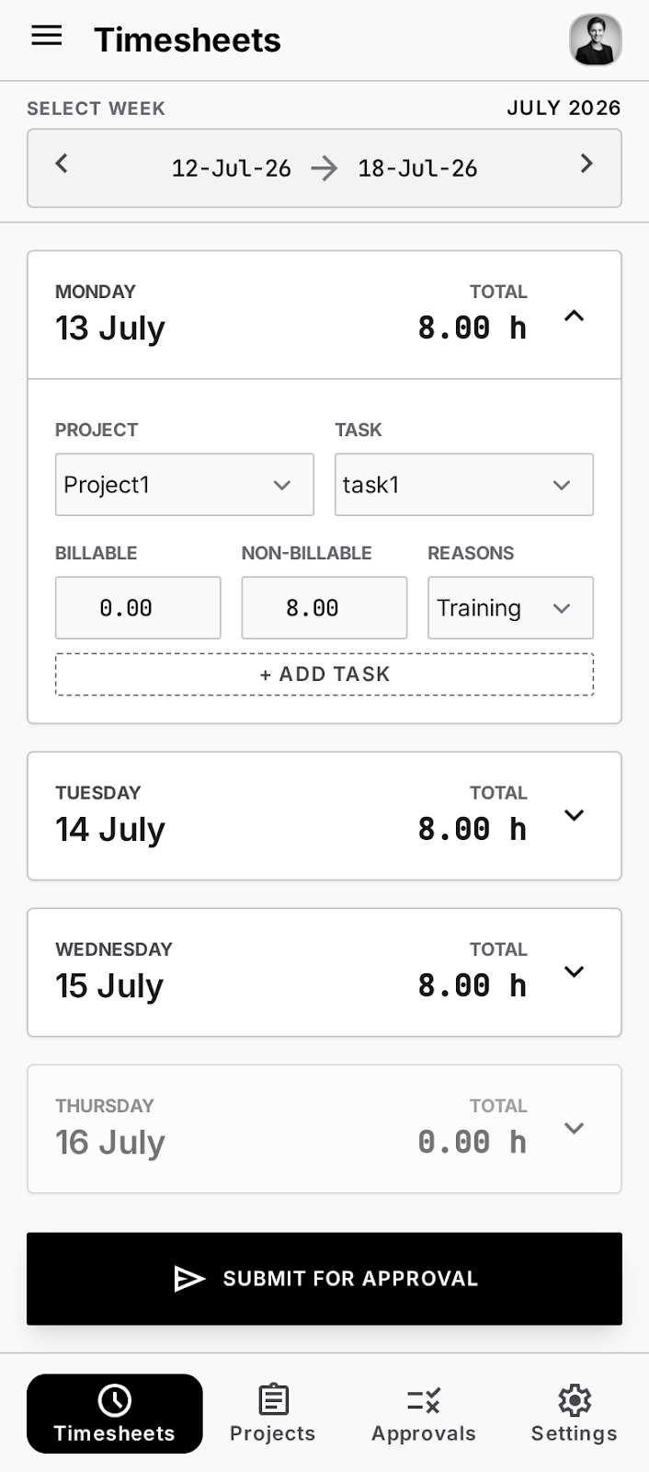

4.2.1 Timesheet Adjustments
Corrections to accrual - based on the corrections that are done post payroll cutoff, book close, client cycle, there will be different logic to extract changes. The adjustments will be passed to subsystems based on reversal of earlier entries for that employee for that day and posting the new entries.
- Reversal – based on correction of time to last period either due to manager / employee making changes or client driven a change entry for that period, both + and -ve should be generated based on the situation (logic of net off) (Do we need a email intimations)
- Default corrections – this is more for changes by employee during the period where organisation has used default a values and based on actual cutoff date of employee there is a change (like project allocation was not done on time). Same effect for manager cutoff (What should be the flow from screen side)
  - For example, if the project allocation is not completed on time and it is already the 28th of the month, the organization may proceed with the month-end close using the existing project allocation to close the books. Once the project allocation is updated, a correction can be submitted. The old project will have a reversal for the affected period (e.g., three days), and the corresponding entries will be applied to the new project.
- Client based changes – while we have an installation that has a certain quantity of time approved by manager there is always a possibility that client does not approve the same and this has to be reversed or corrected – facility to capture, approve and create JV needed (What should be the flow from screen side)

Any such above corrections that are done after the book closure are handled as adjustments
- Adjustments to time can be done for 3 months from the current open period. (Should this be a part of control table)
- Any adjustments done to the timesheet must be flagged as they are adjusted. This should be maintained for each employee at day level.
- These adjustments must be submitted and approved by the manager
- There should be an action date capture- date on which adjustments were approved by manager
- If there was a project change or WBS change that was done backdated (ie, after book close)
  - If the month has already been closed, both the old project and the new project shall be impacted.
  - The system shall allow the records to be marked as Rejected or with a reason indicating that a correction is to be done.
  - The correction shall be submitted to the manager for approval.
  - The manager shall approve the entire change in the subsequent month.
  - The system shall handle backdated Project Changes and WBS Changes that occur after the books have been closed based on the Control Calendar.

4.2 Manager confirmation
Once the employee confirms the time, managers can review, approve or reject the time.
Rules
- Rejection – rejection reason to be captured –LOV as below. Also, provide an option to provide rejection remarks
  - Manager driven
  - Client driven
  - Absence
- Manager can edit and approve time (What is this edit means can he edit the time emp has applied)- change any fields
- There will be delivery cut-off date before which manager must approve the timesheet. This date will be available in the period control table. (Should there be a disclaimer to manager like when is the delivery cutoff date) - Delivery cut-off (manager approve)
- Monthly – defaulting login and should be based on different cutoff dates (separate documents for cut off dates)
Landing page – list of all projects to which he is the manager. Filter for month and project
Data field | Description | Field Type | Input Type | Source System | Mandatory  (Y/N) | Sample Data
Month/year | Month and year of the time submitted by employees | Varchar | Auto populated | - | Y
Project name | Name of the project | Varchar | Auto populated | Project master | Y
Project number | Unique id of the project | Varchar | Auto populated | Project master | Y
Timesheet start date | Start date of the timesheet for the month | Date | Auto populated |  | Y
Timesheet end date | End date of the timesheet for the month | Date | Auto populated |  | Y
Details | Hyperlink to go into employee details |  |  |  | Y
Status | Status of the timesheet – approved or not by manager | Character | Auto populated |  | Y
Approved On | When the timesheet was approved | Date | Auto populated |  | Y if status is approved

SAMPLE SCREEN
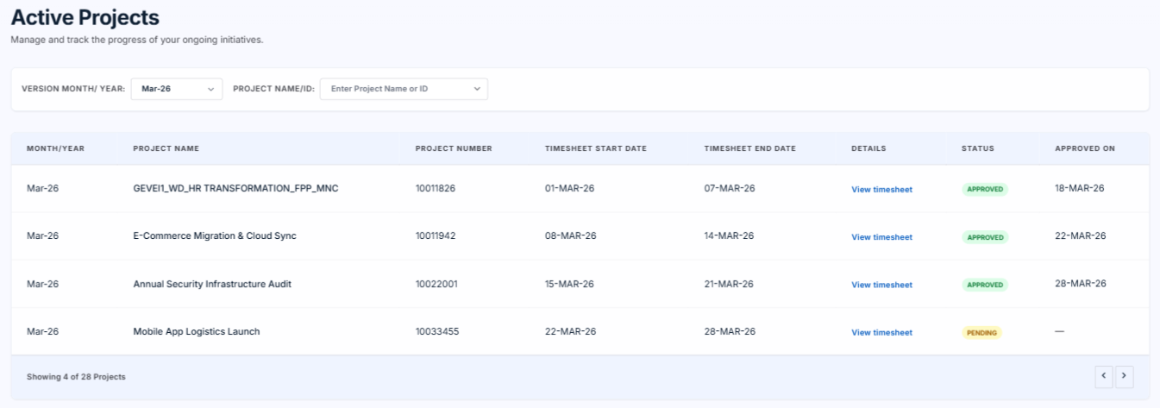

View Timesheet
Upon clicking on one project, all the employee details must be displayed.
Data field | Description | Field Type | Input Type | Source System | Mandatory  (Y/N) | Sample Data
Check box
Employee id |  | Varchar | Auto populated | Project resource management (resource allocation) | Y
Employee name |  | Character | Auto populated | Project resource management | Y
Billing status |  | Character | Auto populated | Project resource management | Y
Billable Hours |  | Number | Auto populated | Employee TS | Y
Non billable hours |  | Number | Auto populated | Employee TS | N
Leave |  | Number | Auto populated | HR | Y is leave is applied in HR system
Unbilled reasons | Show this at day level only. | Character | Auto populated | Employee TS | Y is Non billable hours are entered
Total hours |  | Number | Calculated | - | Y
Cap type |  | Character | Auto populated | Revenue model definition based on the base location of the employee | N
Cap hours |  | Number | Auto populated | Revenue model definition based on the base location of the employee | Y if cap type is not empty
View | Link to view day wise details of the employee |  |  | - | Y

Rules:
- No data will be editable at the month level.
- Employee details can be fetched from the project resource management module. Currently, resource allocation is the temporary master.
- Hours should be displayed at WBS level.
- Total hours = billable hours + non billable hours + leave
- Unbilled reasons can be edited by the manager. This must be displayed at the day level only and not in the page where all employees are displayed
- If manager edits anything, the changes should be maintained in the audit table but no need to show it in the front end.
- Cap hours is for information purposes only. There is no need of any validations
- Manager Approves once in a month only - what is confirmed here
- There should be an option for manager to select all or some employees and approve together.
Sample screen
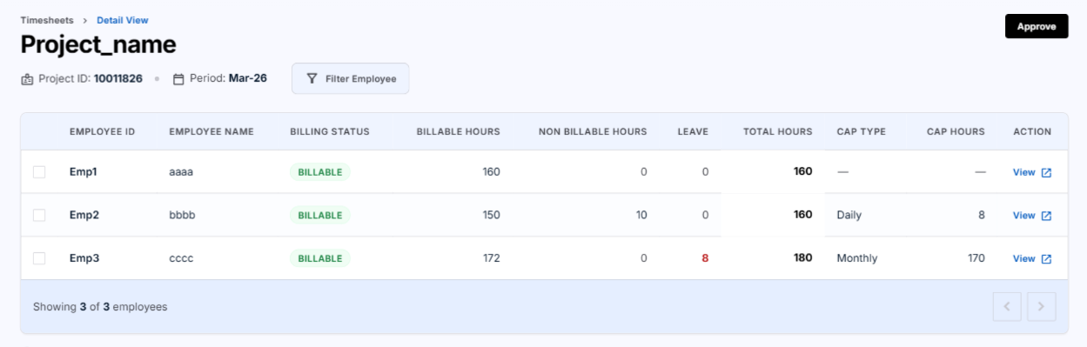
Day wise Details
Upon clicking the details link of an employee, same details that was shown in the previous page must be shown day wise of the period.
Sample screen
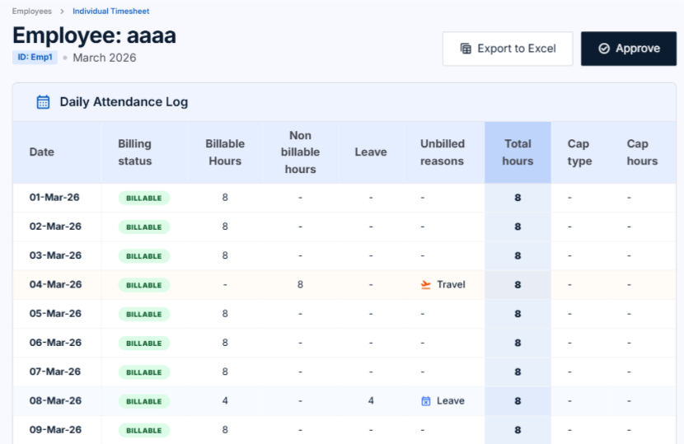
Action | Status | Flag
While logging in | Pending
Once approved | Approved
If Rejected by PM | Rejected
If PM doesn’t approve | Manager Defaulted
Edited and approved | Approved | Overridden and approved

Rules :
- There should be an option to download the day wise details, edit in excel and upload back.
- If manager edits the time, old data should still be available for audit.
- Manager can approve each employee’s timesheet also
- If there are any contractors and there is unbilled hours for any day, there should be an exception approval needed. – provision for workflow

4.2.1 Leave Loss Coverage
This is a screen inside the manager timesheet module that is invoked for Capacity projects where Leave loss is checked as Yes in the revenue model definition. This will display all the employees who had an absence record(except maternity and LOP) for the period in consideration (payroll cutoff will not have this) on 1 column with employee details, date and hours and on the other side against each entry will have ability to capture an employee id – this drop down will display only employee who are marked as Unbilled in the same project and who are not absent on that date in consideration. Once each line is filled it is approved – treatment is as follows – for all FCP project the absence hours where LL is marked as Yes the same will be considered as billed hours. This will be used in appendix of the invoice printing.
Data field | Description | Field Type | Input Type | Source System | Mandatory  (Y/N) | Sample Data
Employee id | Employee id of the employee who has an absent record | Varchar | Auto Populated | HR | Y
Employee name | Employee name of the employee who has an absent record | Character | Auto Populated | HR | Y
Date | Date on which the employee has an absent record | Date | Auto Populated | HR | Y
Hours | Number of hours for which employee was absent on that date | Number | Auto Populated | HR | Y
Unbilled Employees | List of employees marked as non billable | LOV | Input | Project resource management | Y

Sample screen
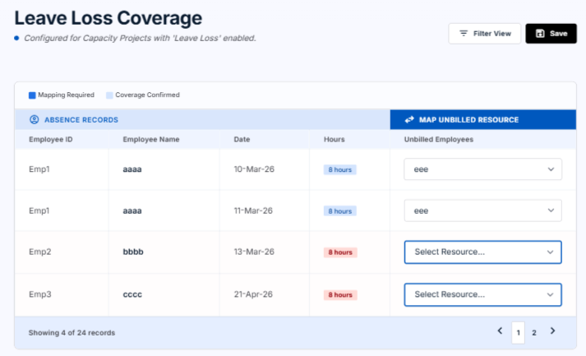

Rules
- This screen is visible only if Leave loss coverage is marked as Yes in revenue model definition
- this screen will be entered by PM
- Unbilled employees should not be absent on the same day selected
- One unbilled employee cannot be mapped to 2 absent employees for the same day
- Employees on LOP or maternity leave are not considered under absent employees
- This data will be used in annexure part in the printing module

4.3 Client Timesheets
There should be a screen called “Client timesheet” to upload and maintain Customer-approved Timesheets for each Project and Billing Period.
(R we just storing this as a document record or any validation from the Manager is needed)
Rules:
- The system should display the previous month's approved or defaulted timesheet for reference. The timesheet may be displayed week-wise or for the entire month.
- The system shall provide the ability to attach multiple customer timesheet documents.
- The customer timesheet upload functionality shall be maintained separately from the main application.
- Customer timesheets shall not be part of the billing close submission process, as customer-signed timesheets may not be available at the time of close and may be received one or two weeks later.
- This feature is intended to enable the collection of customer timesheets after the billing close process.
- This feature is for employees but not required in the mobile app.
- There will be no approval for this.

Sample screen
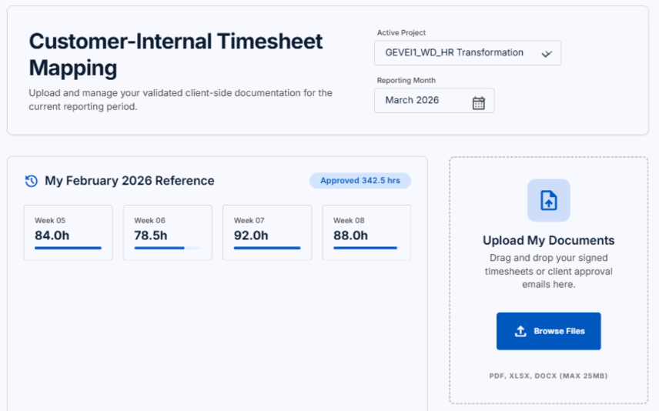

4.4 Salary stopping tool (For Whom the page should be visible)

  - There will be Payroll Cut-off Date, which is different from the month-end close that is defined in the period control table.
  - On the payroll cut-off date, the system should identify all employees and contractors who have not submitted their timesheets or whose timesheets are not approved by their manager, based on the applicable business rules.
  - The identified records should be moved to a separate bucket for payroll processing.
  - The salary hold process will be applicable only for payroll. The month-end close and accounting processes will continue as normal and will not be affected.
  - The system should retain the identified records separately without impacting the remaining payroll processing.
  - The system should provide a screen where an employee can view the dates for which timesheets have not been submitted.
  - The employee should be able to submit the pending timesheets along with a reason (e.g., correcting the number).
  - The submitted timesheets should be routed to the employee's manager for approval.
  - Once approved, the record will be sent back to payroll, and the held salary can be processed in the subsequent payroll cycle.
  - The accounting process will not be affected. Only the salary will be placed on hold and released after the required approval process is completed.

automatically if the employee timesheet is defaulted it should show the list of employee who has failed to submit by the cutoff date the time sheet should show like submitted with default value and it should be lock and edit is not allowed unless manager edits it
Does this have dependency on the invoice which is sent to the client ??

Sample screen
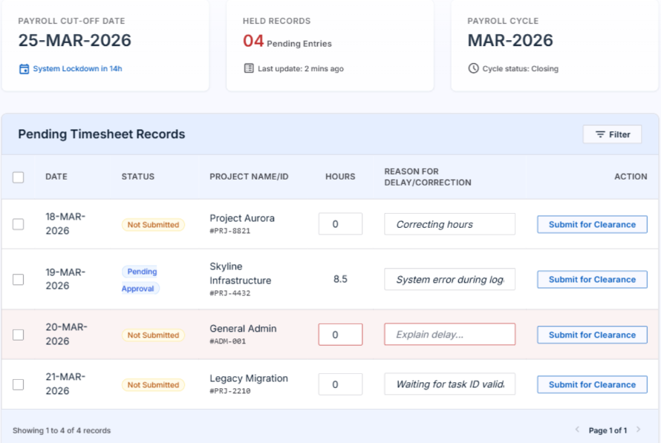

Integrations
Integration to accrual
Based on the open period, there will be a row created in accrual based on a job that is run every month by finance. For that open period, the timesheet data must be displayed in accrual employee wise, employee day wise at WBS level.
There will be also one separate row for any adjustment entry done in the timesheet. Adjustments can be because of different reasons (explained in section 7).

Reports

Scenarios

Advance close
- In exceptional business situations, Finance may decide to perform an Advance Close. For example, instead of following the regular closing cycle(by 10th of a month), the close process may be initiated on 28 June and completed by 2 July.
- when there is a need to close books before time period there will be a special feature where default hours are approved as through manager has approved the time and closure is done.
- In these cases, there should be an ability to mark these defaulted values as “Advanced close” so that employees can come in and later change the default hours to actual. This change must be captured as a flag at each employee day level.

Pre-Requisites

Technical Architecture

Design Consideration
<<specific design details that have an impact on the module / sub module and also on other modules like integration points, expansion hooks, AI>>

Technical Solution Components
<<. Component level details including detail design>>

Error Handling and Retry Mechanism
<<specific details of what to trap, how to report and retry attempts including reversals>>

Data Model
<<detail tech design of database- this can be a separate document since it will involve table design, field explanation, dependency, keys…>>

NFR (Performance, IT Security, etc.)
<<Expectation on performance, it security, access control, product or platform details, fitment to ERP, flexibility expected, integration framework, hosting details>>

Compliance
<< This should be around BISO, CISO expectations and also reports that we will publish to our clients on a regular basis>>

Points not covered

Population of time
- Unbilled hours – based on standard hours and % distribution the balance a hours should go to a default project. Also, the resource and be marked as Billed or Unbilled with the second is considered as unbilled hours. Absence is also unbilled from a client perspective ie for revenue but not for cost. The impact for contractor should be different and should always billed unless exception approval is done
- Employee time is country based - logic to handle, local time, shift, workdays and deputation
- Additional features
  - Work day calendar – already detailed above
  - Holiday working - This logic is for both for Payroll integration and also Revenue calculation – in case of Holiday working based on policy both internal and statuary we will have to do revenue impact while cost impact will come from payroll
  - Shift – a value that is used in both Revenue calculation based on client setup and provided to payroll
  - OT – same as above
  - Capping - This is captured in the system as setup at a opportunity level. It is applied into the manager screen – displayed as data and allows managers to make necessary corrections
Open questions

For example before we apply the last week timesheet our cutoff date has come and we have sent the default hours only for that week and rest all week is submitted and approved to accrual and rest of the process is done

Now the on 1st august employee is applying the time sheet and managers approves it , now this data will go as an adjustment to accrual
Is this understanding crt

